NAME: RENUKA WANKHADE

ROLL NO:213046

PRN NO:22211581

DBMS Assignment - 5

# SQL Joins

SQL JOINS are used to retrieve data from multiple tables. A SQL JOIN is performed whenever two or more tables are listed in a SQL statement.

There are 4 different types of SQL joins:

* SQL INNER JOIN (sometimes called simple join)
* SQL LEFT OUTER JOIN (sometimes called LEFT JOIN)
* SQL RIGHT OUTER JOIN (sometimes called RIGHT JOIN)
* SQL FULL OUTER JOIN (sometimes called FULL JOIN)

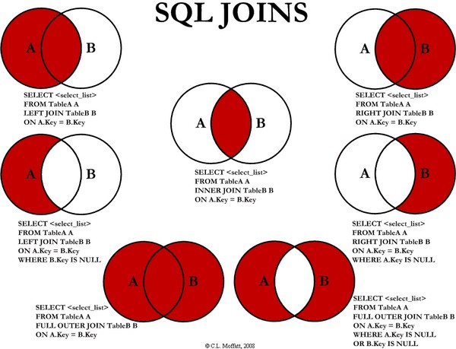

# Assignment 5 Lab Questions

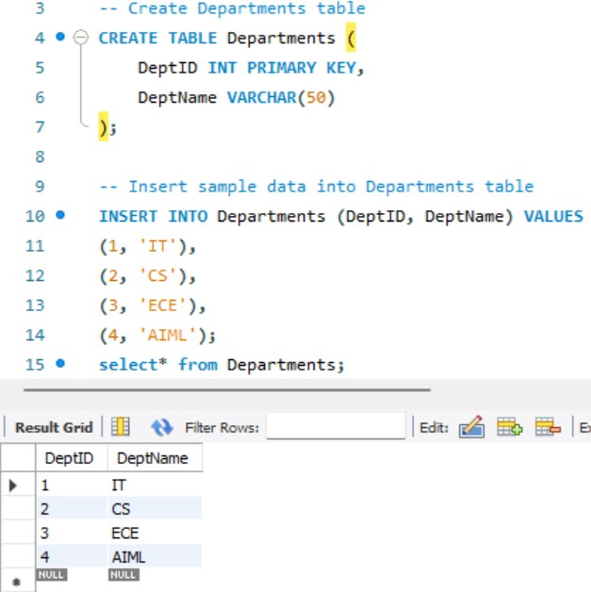Using SQL joins, obtain the following information from VU Library Database Database and all tables

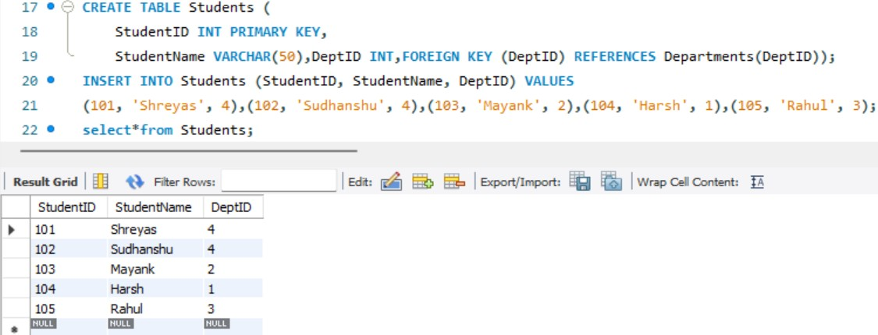

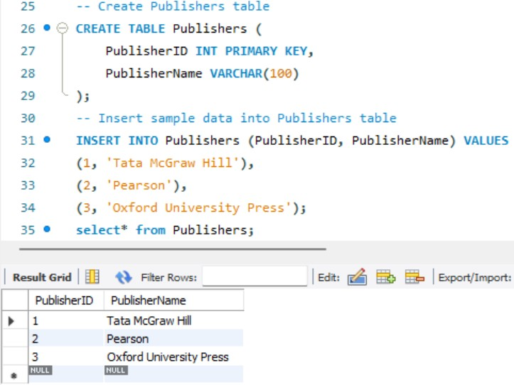

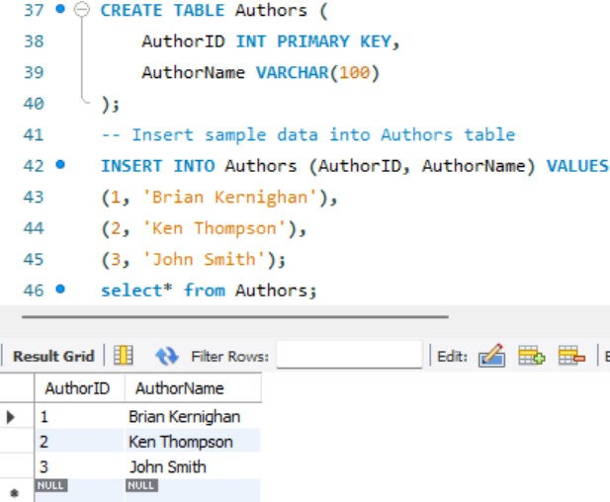

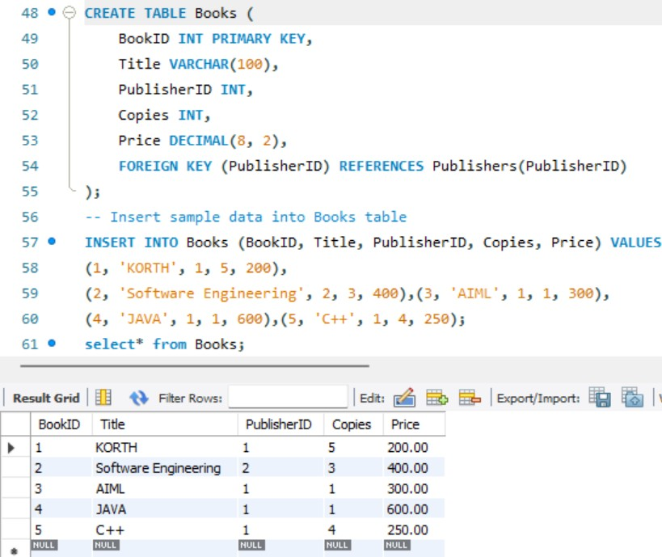

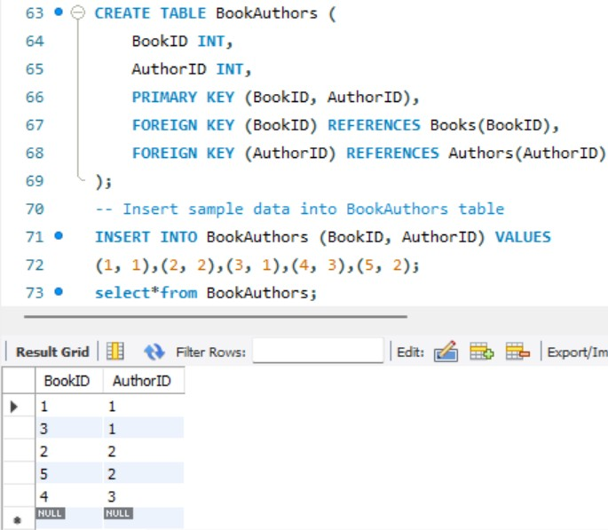

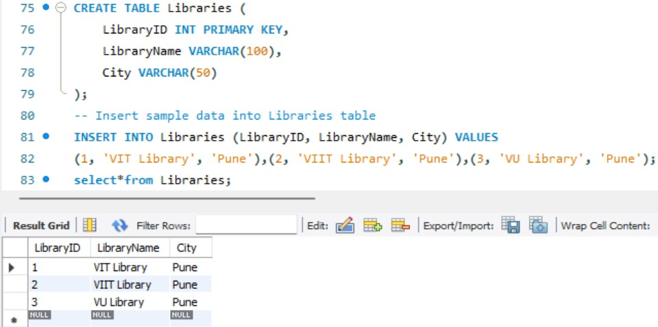

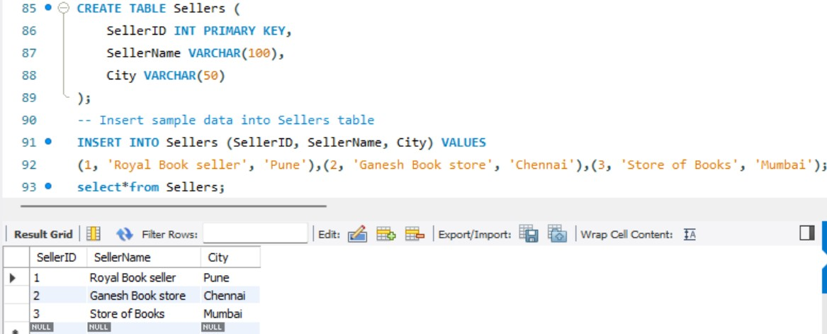

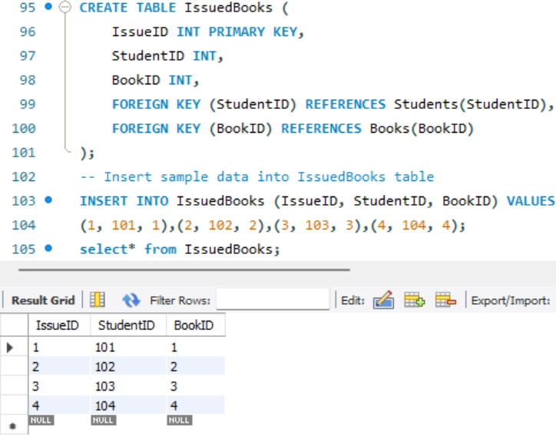

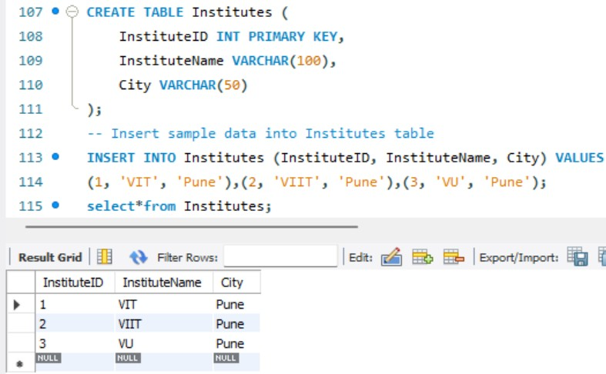

* 1. 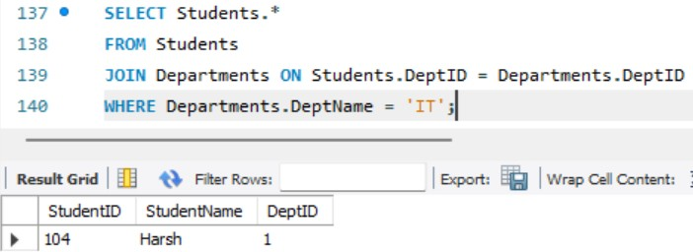**Students in the IT department.**
  2. **Books in VIT library.**

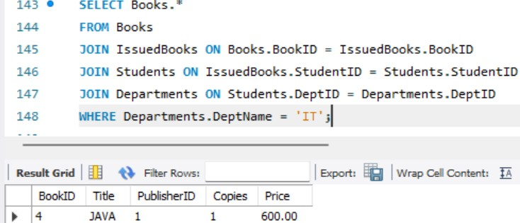

* 1. 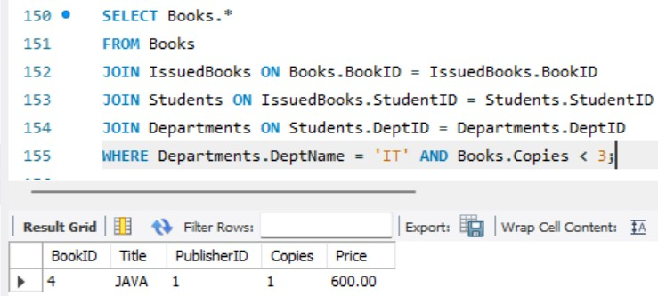**Books with less than 3 copies in VIT Library.**
  2. 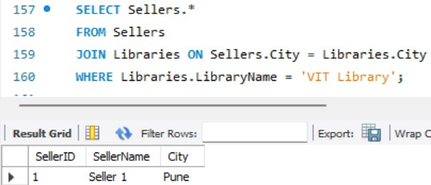**Sellers in the same city as VIT.**
  3. 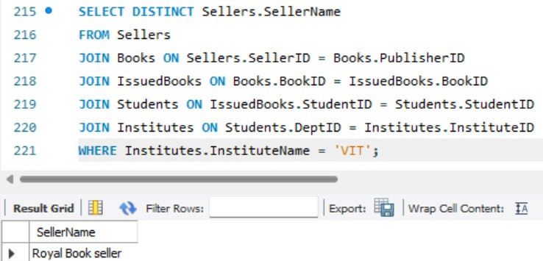**Sellers selling books to VIT.**
  4. 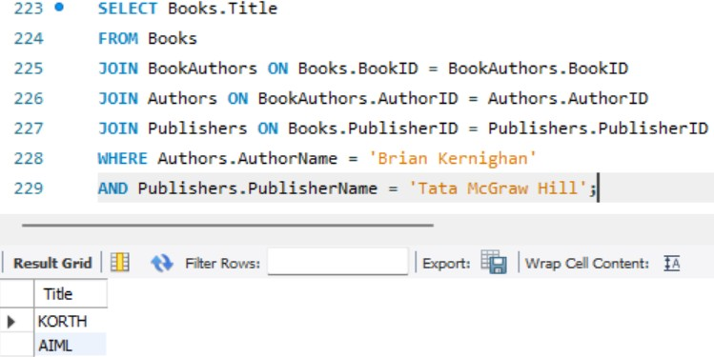**Books authored by Brian Kernighan, and published by Tata McGraw Hill.**
  5. 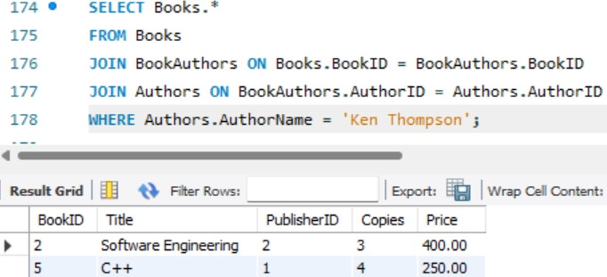**Books authored by Ken Thompson.**
  6. 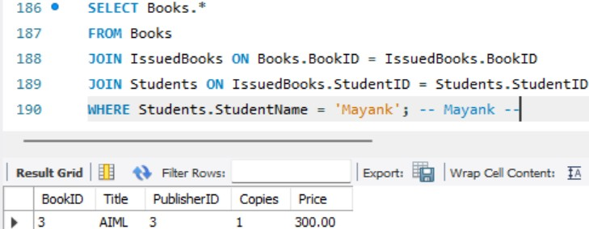**Books issued by Mayank.**
  7. 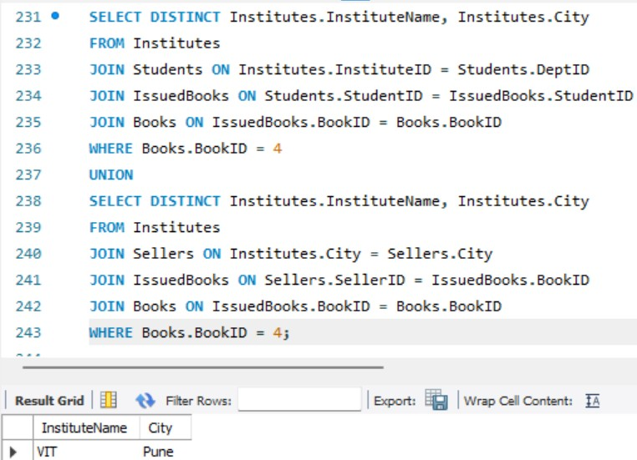**Institutes whose staff and students have issued book with bid 4444. I used bid=4**
  8. 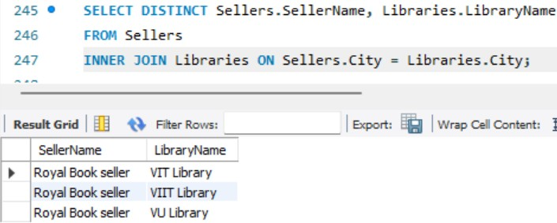**Sellers selling to libraries in the same city.**
  9. 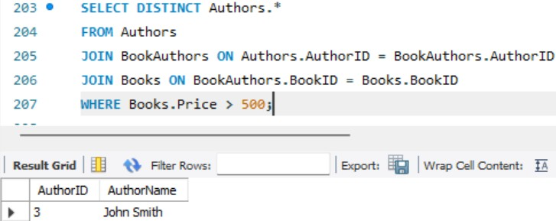**Authors with books costing more than Rs 500.**